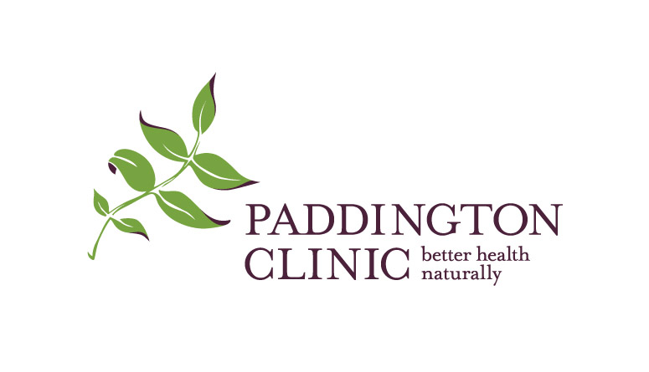
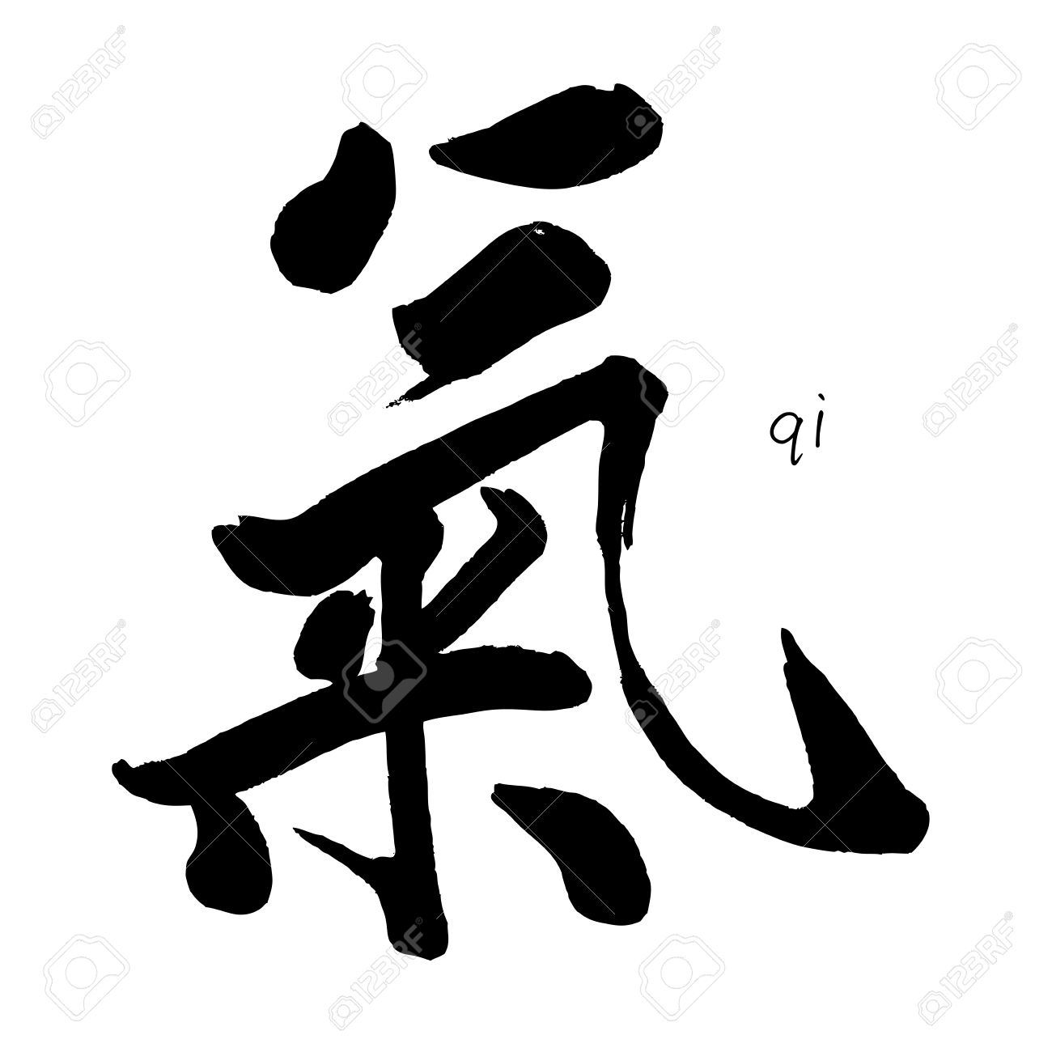
REGISTRATION FORM
Please complete the following details (this is a fillable form) and email or print and post to Paddington Clinic Seminars Suite 12/261 Given Terrace, Paddington QLD 4064.

Melbourne Seminar

Dr Suzanne Robidoux

Cost for 4 day Advanced Scalp Acupuncture seminar.

Full price $1716 (includes GST $156)
Early bird $1485 (includes GST $135) If paid in full before 1st October 2019

Please book me for the following seminar:

Scalp Acupuncture Advanced Training Melbourne by Dr Suzanne Robidoux
Friday 6th - 9th December 2019

The number of participants is limited and a place will be secured only with full payment.

NB: for each day attended 7 CPD points approved by AACMA

First name Surname
Address
Mobile
Email
Web address
I am a practitioner

I am a student

Payment method

Card number / / / Exp

Amount payable: $

I enclose a cheque / money order payable to Paddington Clinic
Direct debit: BSB 084 004 Acc. # 47694 6010
Please mark it Seminar and include your Name
Contact details and further information
Paddington Clinic
Peter Delaney +61 411537398
fpdelaney@gmail.com

